**Water Level E-Mail Notifier Using Raspberry Pi 3 & 4, Node Red & Ultrasonic Sensor**

Step 1: connecting the Ultrasonic sensor to the Raspberry Pi

Connect the circuit as shown below

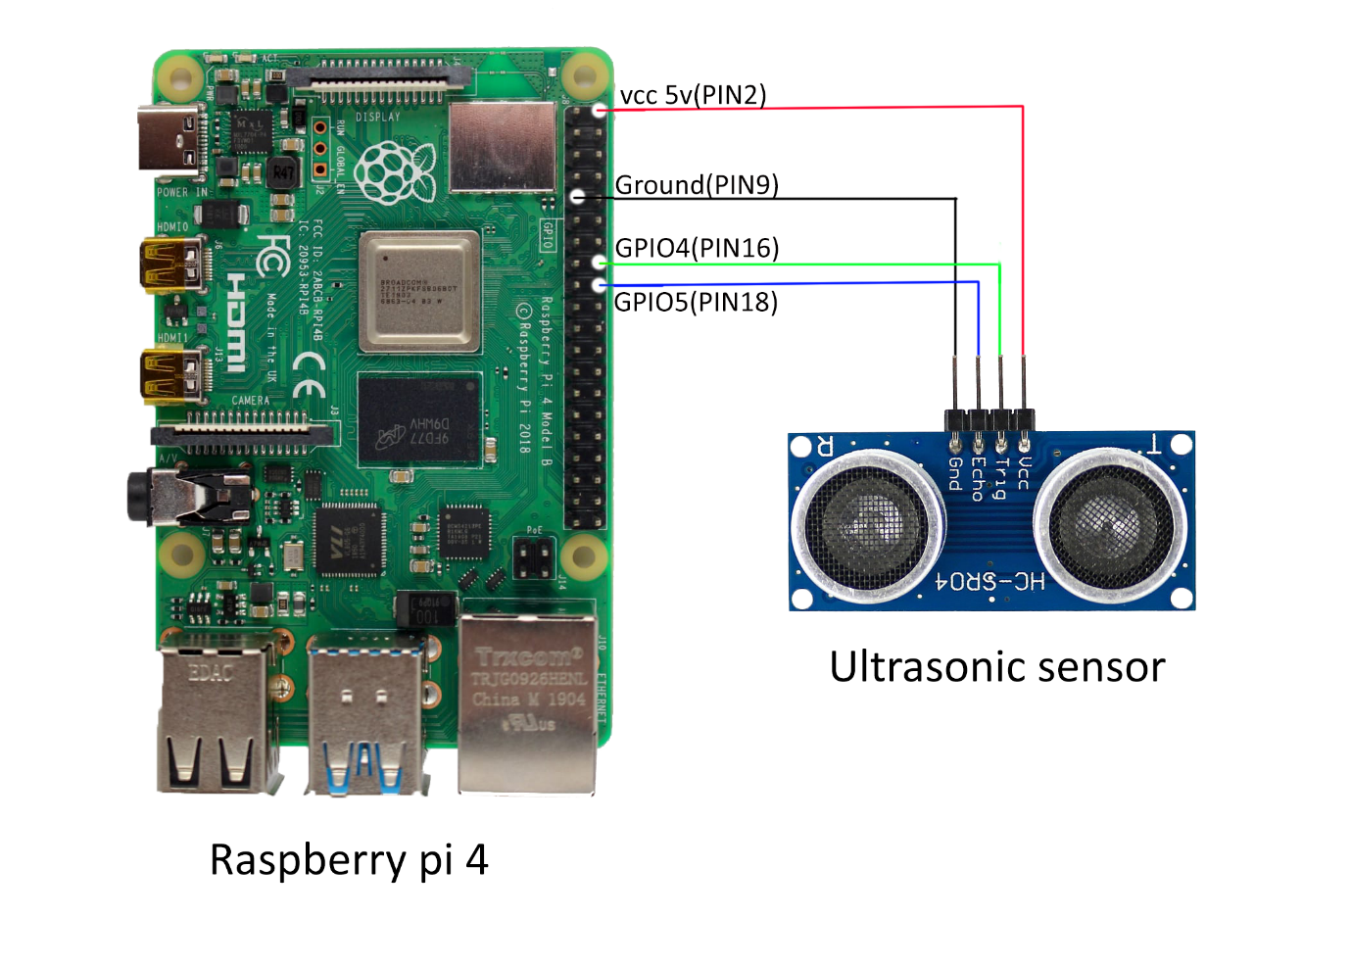

Step 2: Setting up the Raspberry pi Node red

Open the Raspberry pi and open the Node Red Application. Here We have two ways to open the Node Red application.

1. Go to menu->Programming->Node Red and launch the application

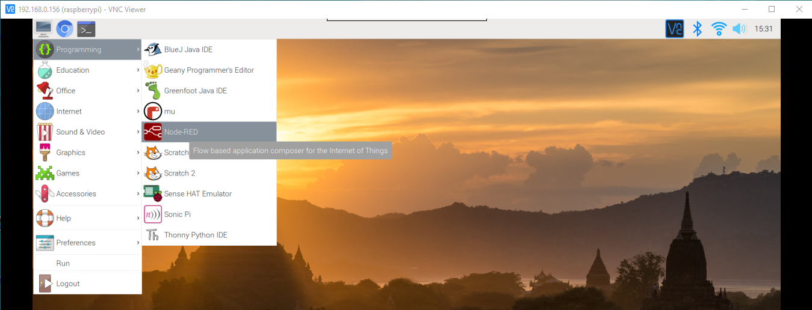

1. Open the raspberry pi Terminal and type the following command

**Sudo node-red**

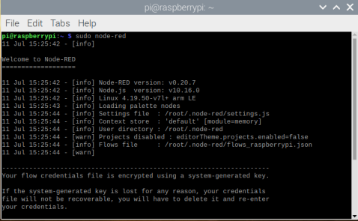

Note: Node red is preinstalled in Raspberry pi along with the os. If there is no Node red installed in Raspberry pi you need to install. To Install the Node red, follow the below link

[Node Red installation Guide](https://nodered.org/docs/getting-started/raspberrypi#installing-node-red)

After launching the Node red application, you will see an IP Address as shown in below

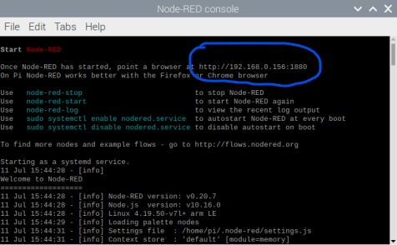

Copy the IP Address and paste it on Browser. Here you will see the Node Red work flow editor as shown below

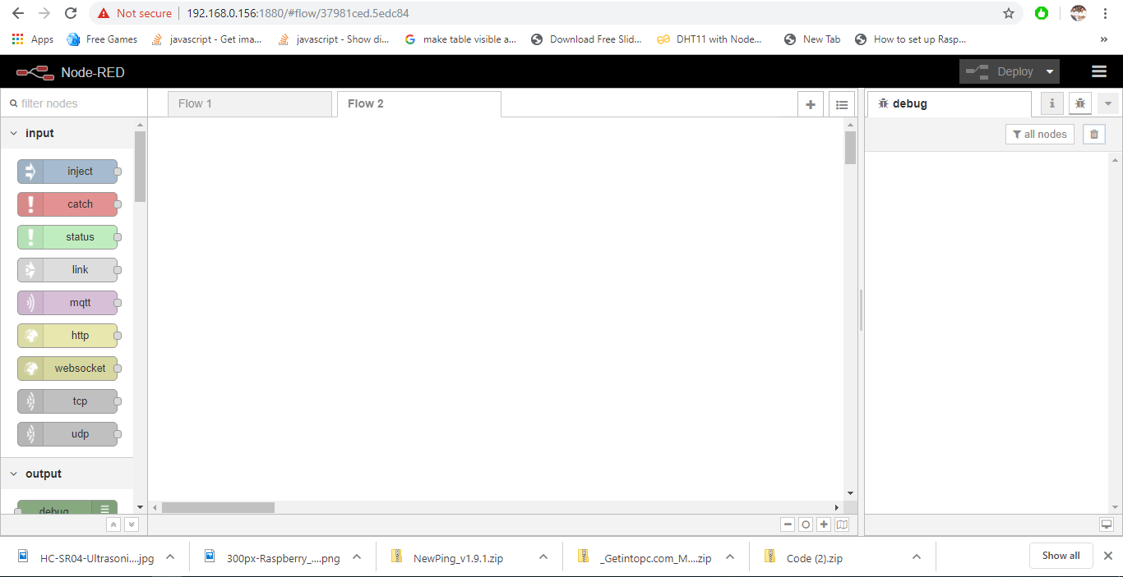

Here you have to connect the nodes as shown below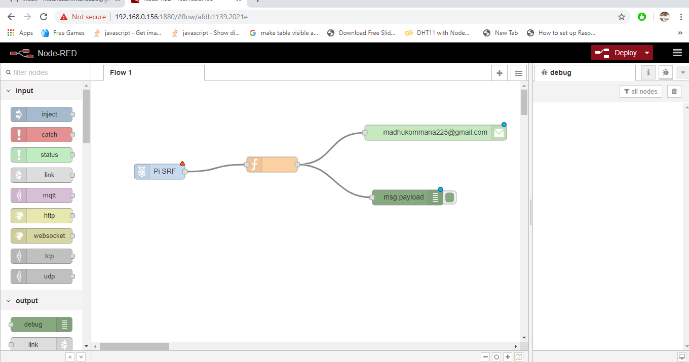

The detailed information of each node is explained below

1. rpi srf node:

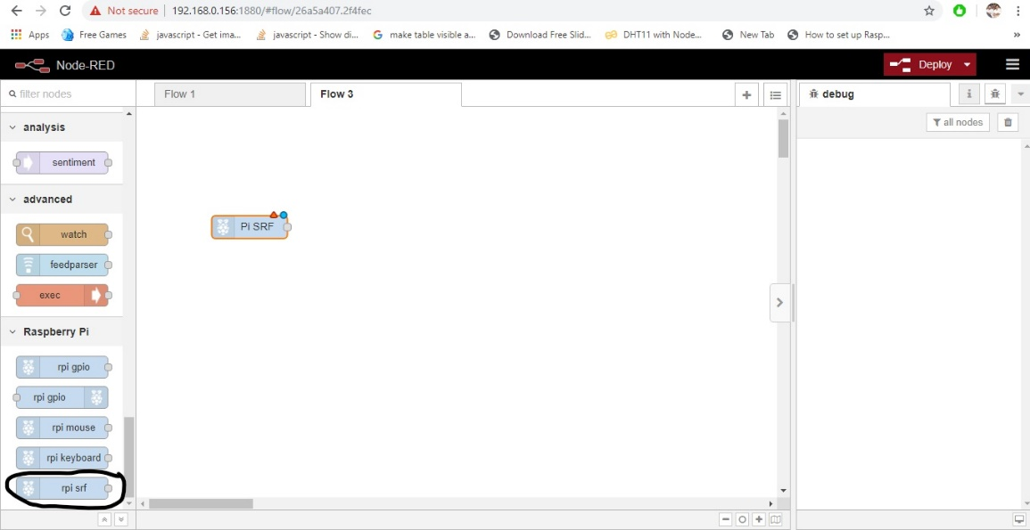

Drag and drop the **rpi srf** node to the work flow editor as shown in above image and configure the node as shown in below.

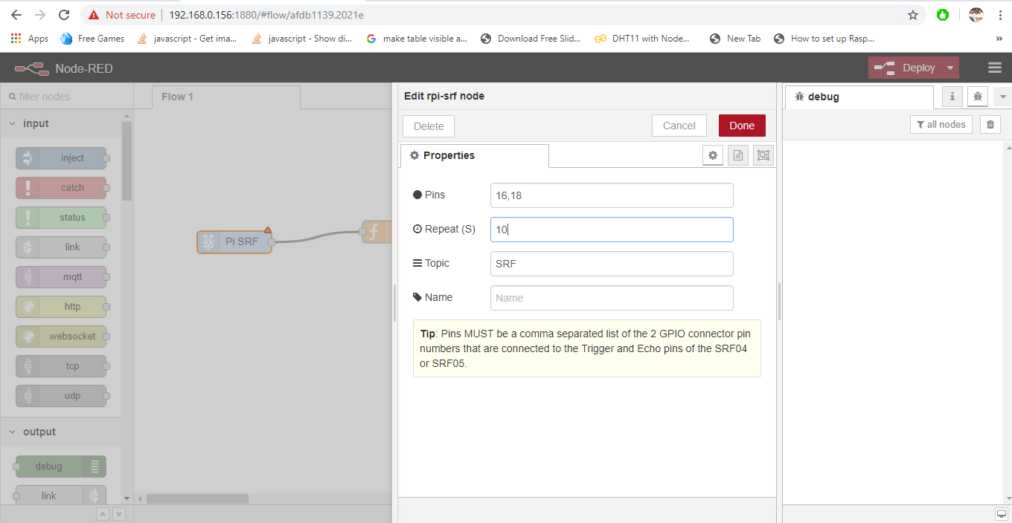

From the above figure

Pins: Represents the Trigger & Echo pins of ultrasonic sensor which is connected to the raspberry pi pins.

Mention the pin numbers of raspberry pi in the pin’s column

Example: 16(GPIO4),18(GPIO5)

Note: If you didn’t find the **rpi srf.** Go to the menu (three Horizontal lines at corner of the Node red page) and go to MANAGE PALATTE and go to install and search for ultrasonic then install the library as shown in below

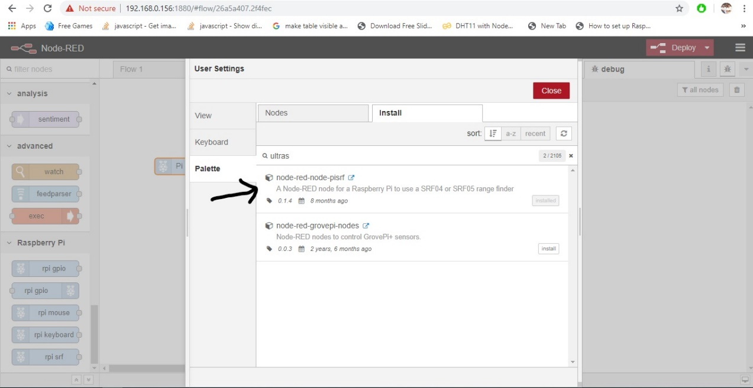

1. Function Node: Here we are writing a logic as shown in below. Copy and paste the code in function node

**if (msg. payload <=5) //if the sensor is less than or equal to 5 then we get tank is filled message**

**{**

**msg. payload = "Tank filled";**

**}**

**else if (msg. payload >= 20) //if the sensor is greater than or equal to 5 then we get tank is Empty message**

**{**

**msg. payload = "Empty";**

**}**

**return msg;**

1. Email Node: It is used to send the messages to the Email. The configuration of Email node is shown in below

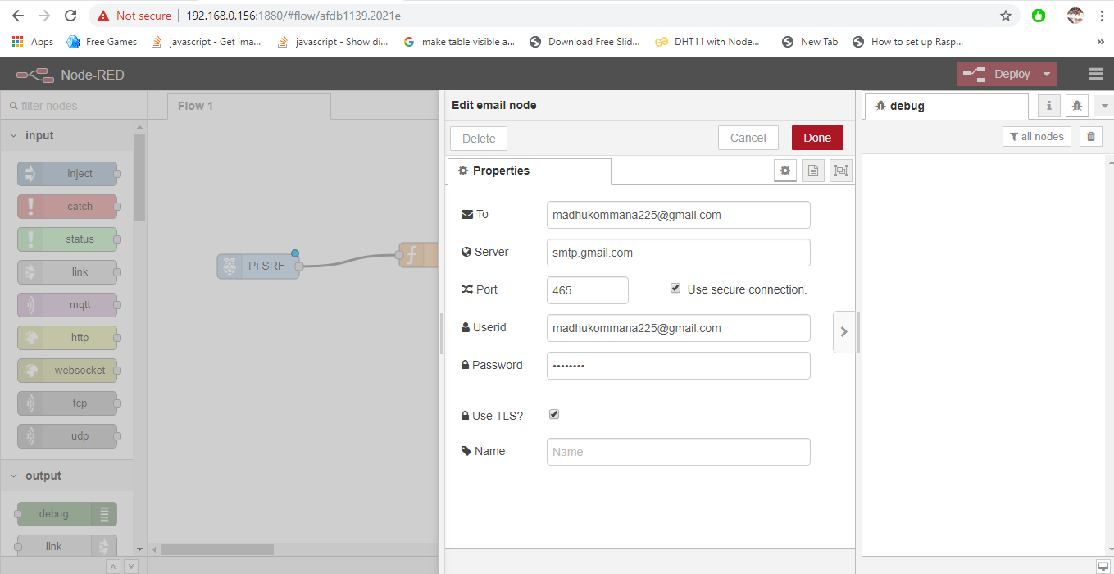

1. Debug node: It is used to display the information in Node red editor

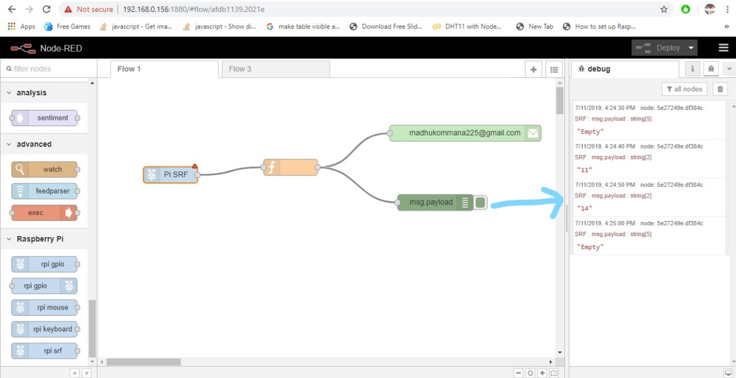

Step 3: Running the program

After all the connections are made open the node red editor and click on deploy button.

Here you will see the output results by side in node red editor as shown above

Now open your registered mail and check the results by varying the ultrasonic sensor.

The output results of mail are as shown in below.

